CLASS EXERCISE DAY 7: TESTNG

QUESTION NO:1

TASK:1

| package com.Test.Test; import static org.testng.AssertJUnit.assertTrue; import org.openqa.selenium.WebDriver; import org.openqa.selenium.chrome.ChromeDriver; import org.openqa.selenium.chrome.ChromeOptions; import org.testng.Assert; import org.testng.annotations.Test; import io.github.bonigarcia.wdm.WebDriverManager; public class AppTest {  @Test  public void shouldAnswerWithTrue()  {  ChromeOptions co=new ChromeOptions();  co.addArguments("--remote-allow-origins=*");  WebDriverManager.chromedriver().setup();  WebDriver d=new ChromeDriver(co);  d.get("https://demo.wpeverest.com/user-registration/guest-registration-form/");  d.manage().window().maximize();  String actual=d.getTitle();  String expected="Guest Registration Form - User Registration";  Assert.assertEquals(actual, expected);  } } |
| --- |

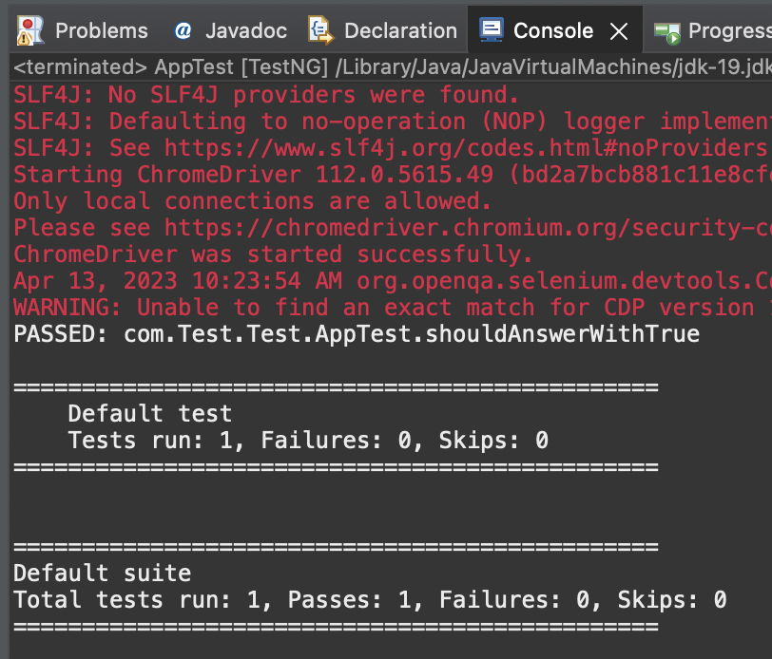

QUESTION NO:2

TASK:2

| package com.Test.Test; import org.testng.Assert; import org.testng.annotations.Test; public class Calculator {  @Test(priority=1)  public void Div() {  int n1=10;  int n2=30;  int res=n2/n1;  Assert.assertEquals(res,3);    }  @Test(priority=2)  public void Mul() {  int n1=20;  int n2=30;  int res=n1*n2;  Assert.assertEquals(res, 600);    }  @Test(priority=3)  public void Sub() {  int n1=50;  int n2=20;  int res=n1-n2;  Assert.assertEquals(res,30);    }  @Test(priority=4)  public void Add() {  int n1=300;  int n2=100;  int res=n1+n2;  Assert.assertEquals(res, 400);  } } |
| --- |

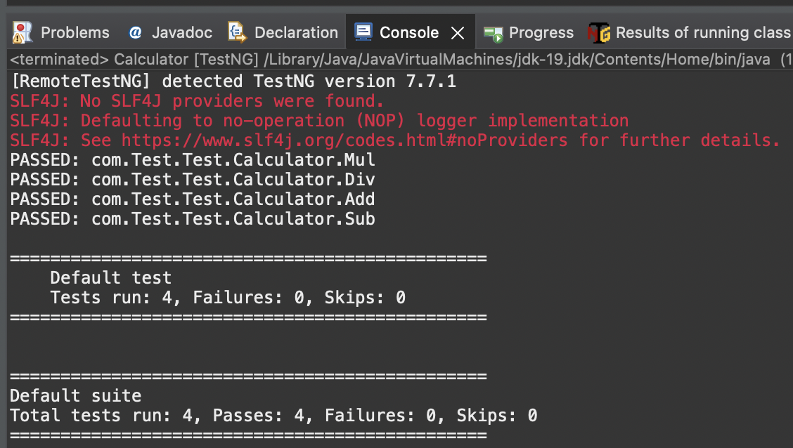

QUESTION NO:3

TASK:3

| package com.Test.Test; import org.testng.annotations.Test; import io.github.bonigarcia.wdm.WebDriverManager; import org.testng.annotations.BeforeMethod; import org.openqa.selenium.By; import org.openqa.selenium.WebDriver; import org.openqa.selenium.chrome.ChromeDriver; import org.openqa.selenium.chrome.ChromeOptions; import org.testng.Assert; import org.testng.annotations.AfterMethod; public class T3 {  WebDriver driver;  @Test  public void print() throws InterruptedException {  driver.get("https://opensource-demo.orangehrmlive.com/web/index.php/auth/login");  Thread.sleep(3000);  driver.findElement(By.xpath("//input[@name='username']")).sendKeys("Admin");  driver.findElement(By.xpath("//input[@name='password']")).sendKeys("admin123");  driver.findElement(By.xpath("//*[@id=\"app\"]/div[1]/div/div[1]/div/div[2]/div[2]/form/div[3]/button")).click();  Thread.sleep(3000);  String text=driver.findElement(By.xpath("//h6[@class=\'oxd-text oxd-text--h6 oxd-topbar-header-breadcrumb-module\']")).getText();  String expText="Dashboard";  Assert.assertEquals(text, expText);  }  @BeforeMethod  public void beforeMethod() {  ChromeOptions co=new ChromeOptions();  co.addArguments("--remote-allow-origins=*");  WebDriverManager.chromedriver().setup();  driver=new ChromeDriver(co);  }  @AfterMethod  public void afterMethod() {    } } |
| --- |

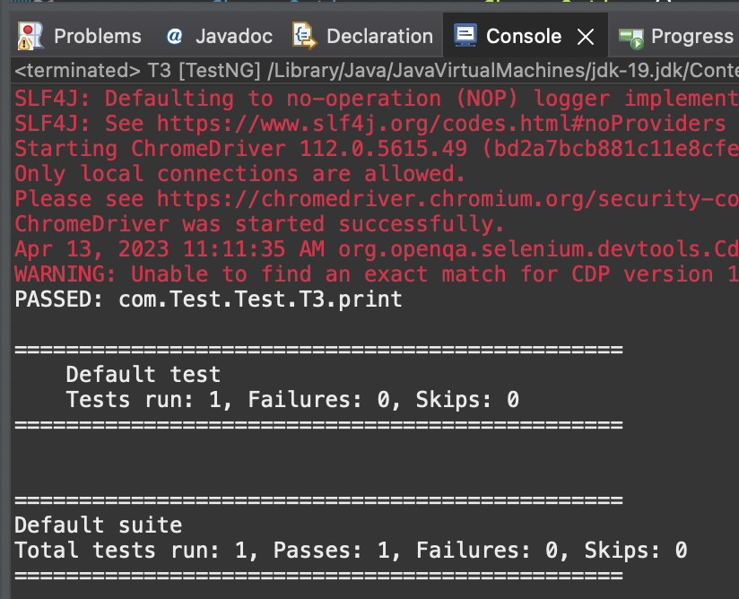

QUESTION NO:4

TASK:4

| package com.Test.Test; import org.testng.annotations.Test; import io.github.bonigarcia.wdm.WebDriverManager; import org.openqa.selenium.By; import org.openqa.selenium.WebDriver; import org.openqa.selenium.chrome.ChromeDriver; import org.openqa.selenium.chrome.ChromeOptions; import org.testng.Assert; public class D7_T4 {  WebDriver d;  @Test  public void login() throws InterruptedException {  ChromeOptions co=new ChromeOptions();  co.addArguments("--remote-allow-origins=*");  WebDriverManager.chromedriver().setup();  d=new ChromeDriver(co);  d.get("https://opensource-demo.orangehrmlive.com/web/index.php/auth/login");  d.manage().window().maximize();  Thread.sleep(2000);  d.findElement(By.xpath("//*[@id=\"app\"]/div[1]/div/div[1]/div/div[2]/div[2]/form/div[1]/div/div[2]/input")).sendKeys("Admin");  d.findElement(By.xpath("//*[@id=\"app\"]/div[1]/div/div[1]/div/div[2]/div[2]/form/div[2]/div/div[2]/input")).sendKeys("admin123");  d.findElement(By.xpath("//*[@id=\"app\"]/div[1]/div/div[1]/div/div[2]/div[2]/form/div[3]/button")).click();  Thread.sleep(3000);  String actual="My Actions";    System.out.println(actual);  Thread.sleep(3000);  String expected=d.findElement(By.xpath("//*[@id=\"app\"]/div[1]/div[2]/div[2]/div/div[2]/div/div[1]/div/p")).getText();  Thread.sleep(2000);  Assert.assertEquals(actual,expected);  System.out.println("Logged in");    }  @Test  public void logout() throws InterruptedException {  Thread.sleep(2000);  d.findElement(By.xpath("//*[@id=\"app\"]/div[1]/div[1]/header/div[1]/div[2]/ul/li/span")).click();  d.findElement(By.xpath("//*[@id=\"app\"]/div[1]/div[1]/header/div[1]/div[2]/ul/li/ul/li[4]/a")).click();  String txt="Login";  System.out.println(txt);  Thread.sleep(2000);  String etxt=d.findElement(By.xpath("//*[@id=\"app\"]/div[1]/div/div[1]/div/div[2]/h5")).getText();  Assert.assertEquals(txt, etxt);  System.out.println("Logged out");    } } |
| --- |
|  |

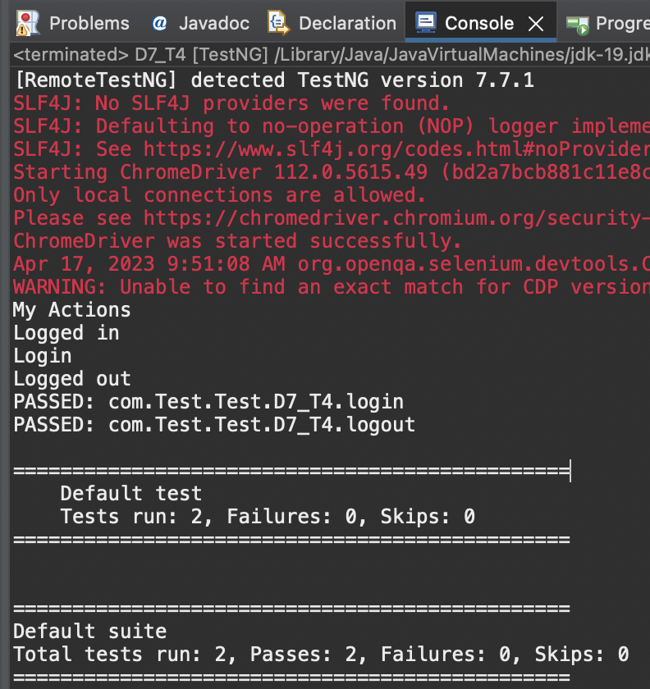

QUESTION NO:5

TASK:5

| package com.Test.Test; import java.util.concurrent.TimeUnit; import org.openqa.selenium.By; import org.openqa.selenium.WebDriver; import org.openqa.selenium.chrome.ChromeDriver; import org.openqa.selenium.chrome.ChromeOptions; import org.testng.Assert; import org.testng.annotations.BeforeMethod; import org.testng.annotations.Test; import io.github.bonigarcia.wdm.WebDriverManager; public class D7_T5_2 {  WebDriver driver;  @Test  public void testCase1() {  String expectedTitle="Domain Names, Websites, Hosting & Online Marketing Tools - GoDaddy IN";  String actualTitle=driver.getTitle();  Assert.assertEquals(expectedTitle,actualTitle);  String CurrentUrl=driver.getCurrentUrl();  String ExpectedUrl="https://www.godaddy.com/en-in";  Assert.assertEquals(CurrentUrl, ExpectedUrl);  }  @Test  public void testCase2() throws InterruptedException{ // Thread.sleep(3000);  driver.manage().timeouts().implicitlyWait(20,TimeUnit.SECONDS);  driver.findElement(By.xpath("/html/body/header/div/section/div/div[1]/nav/div[2]/div[1]/ul/li[1]/button")).click();  driver.manage().timeouts().implicitlyWait(10,TimeUnit.SECONDS);  driver.findElement(By.xpath("/html/body/header/div/section/div/div[1]/nav/div[2]/div[1]/ul/li[1]/div/div[2]/div[1]/ul/li[2]/a")).click();  }  @BeforeMethod  public void beforeMethod() throws InterruptedException {  WebDriverManager.chromedriver().setup();  ChromeOptions co=new ChromeOptions();  co.addArguments("--remote-allow-origins=*");  driver=new ChromeDriver(co);  driver.get("https://www.godaddy.com/");  driver.manage().window().maximize();  driver.manage().timeouts().implicitlyWait(10,TimeUnit.SECONDS);  } } |
| --- |

